|  |  |  |
| --- | --- | --- |
|  | **TECHNOLOGY STACK** | |
|  |  |  |
| Date |  | 08th November, 2022 |
|  |  |  |
| Team ID |  | PNT2022TMID48243 |
|  |  |  |
| Project Name |  | A Novel Method for Handwritten Digit |
|  |  | Recognition System |
|  |  |  |
| Maximum Marks |  | 4 Marks |
|  |  |  |
| **Technical architecture** |  |  |

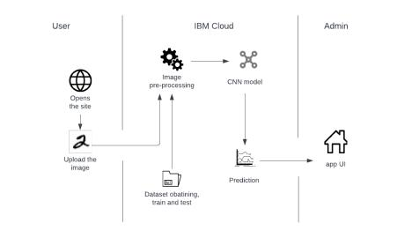

**Table-1: Components & Technologies:**

|  |  |  |  |  |
| --- | --- | --- | --- | --- |
| **S.No** | **Component** | **Description** | **Technology** |  |
|  |  |  |  |  |
| 1. | User Interface | Login through the Web UI | HTML, CSS, JavaScript |  |
|  |  |  |  |  |
| 2. | Application Logic-1 | To download and process data | Python |  |
|  |  |  |  |  |
| 3. | Application Logic-2 | To train and deploy the model | IBM Watson ML service |  |
|  |  |  |
| 4. | Database | User data and inputs | MySQL, NoSQL, etc. |  |
|  |  |  |  |  |
| 5. | Cloud Database | Database Service on Cloud to | IBM DB2, IBM Cloudant |  |
|  |  | store all the data | etc. |  |
| 6. | File Storage | To store user data and the input | IBM Block Storage or |  |
|  |  | digit images | Other Storage Service or |  |
|  |  |  | Local Filesystem |  |
| 7. | Machine Learning Model | Model to recognise the | Image |  |
|  |  | handwritten digits | Recognition Model |  |
|  |  |  |  |  |

|  |  |  |  |
| --- | --- | --- | --- |
| **S.No** | **Component** | **Description** | **Technology** |
|  |  |  |  |
| 8. | Infrastructure (Server / | Application Deployment on | Local, Cloud Foundry, |
|  | Cloud) | Local System / Cloud | Kubernetes, etc. |
|  |  | Local Server Configuration: |  |
|  |  | Cloud Server Configuration |  |

**Table-2: Application Characteristics:**

|  |  |  |  |
| --- | --- | --- | --- |
| **S.No** | **Characteristics** | **Description** | **Technology** |
|  |  |  |  |
| 1. | Open-Source Frameworks | The handwritten digit dataset | MNIST dataset |
| 2. | Security Implementations | Only authorized user can access | SHA-256, Encryptions, |
|  |  | the data, users are authenticated | IAM Controls, OWASP |
|  |  | with passwords | etc. |
| 3. | Scalable Architecture | The model is highly scalable to | 3-tier architecture |
|  |  | see performance changes with |  |
|  |  | design change |  |
| 4. | Availability | The system will be available for | Distributed servers |
|  |  | the users when it is requested |  |
|  |  | handling traffic well |  |
| 5. | Performance | The response time is small and | Cache |
|  |  | user gets their request executed |  |
|  |  | in seconds |  |